Nepal College of information Technology
Imadol lalitpur
Unit Test Spring Semester 2006

Program : BE Semester: Spring
Time : 2hrs Year : 2006
Full Marks:
Digital Signal Processing
Attempt all questions

1. a) Draw the block diagram of DSP. Discuss about the advantages and disadvantages of digital signal processing and analog signal processing.
2. Determine the z-transform of the following signals.
i. x(n) =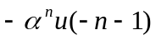
ii. x(n) = 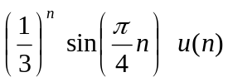
iii. x(n) = 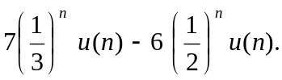
3. Determine the inverse z-transform of
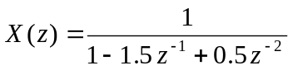 using
i. long division process when
a) ROC : |Z|>1
b) ROC : |Z|<0.5
ii. Partial fraction method
4. Check the time-variant linearity and causality property of the following systems.
a) y(n) = x(n) - x (n-1)
b) y(n) = x(n) . cos w₀n
c) y(n) = e^{x(n)} .
d) y(n) = x(n) + 3x (n+4)

5. Determine the convolution sum of the following systems.

impulse response h(n) = { 1,2 , 1, -1}
↑
i/p signal x(n) = {1, 2, 3, 1}
↑
6. Write short notes on
a) Energy and power signals
b) Unit step and unit impulse sequence.

